Project Planning Phase
Project Planning Template (Product Backlog, Sprint Planning, Stories, Story points)

Date | 7 October 2026
Team ID
Project Name | Script-Controlled ACL – Restrict Record Access Based on Field Value
Maximum Marks | 5 Marks
Product Backlog, Sprint Schedule, and Estimation (4 Marks)
Use the below template to create product backlog and sprint schedule
Sprint | Functional Requirement (Epic) | User Story Number | User Story / Task | Story Points | Priority | Team Members
Sprint-1 | Script-Controlled ACL | USN-1 | As an administrator, I can create a record-level ACL with a script for the table. | 3 | High
Sprint-1 |  | USN-2 | As an administrator, I can check the field value (e.g., Sensitivity) inside the ACL script. | 3 | High
Sprint-1 | Administration & Testing | USN-9 | As an administrator, I can create test users and test records with different Sensitivity values. | 2 | High
Sprint-1 | Field-Value Based Record Restriction | USN-4 | As an authorised user, I can open a Confidential record assigned to me. | 2 | High
Sprint-1 |  | USN-6 | As an unauthorised user, I cannot open or see a Confidential record. | 2 | High
Sprint-2 | Reusable Access Logic | USN-3 | As an administrator, I can move the access logic into a Script Include for reuse. | 3 | Medium
Sprint-2 | Operation Coverage | USN-5 | As an authorised user, I can see the allowed records in the list view and reports. | 2 | Medium
Sprint-2 |  | USN-10 | As an administrator, I can apply the ACL to the write operation (edit / update). | 3 | Medium
Sprint-2 | Administration & Testing | USN-7 | As a security officer, I can test the ACL by impersonating different users. | 3 | High
Sprint-3 | Field-Value Based Record Restriction | USN-11 | As an administrator, I can make sure an empty or unexpected field value is denied by default. | 2 | High
Sprint-3 | Administration & Testing | USN-8 | As a security officer, I can review the ACL script to confirm the rule for audits. | 2 | Low
Project Tracker, Velocity & Burndown Chart: (4 Marks)
Sprint | Total Story Points | Duration | Sprint Start Date | Sprint End Date (Planned) | Story Points Completed (as on Planned End Date) | Sprint Release Date (Actual)
Sprint-1 | 12 | 6 Days | 12 Oct 2026 | 17 Oct 2026
Sprint-2 | 11 | 6 Days | 19 Oct 2026 | 24 Oct 2026
Sprint-3 | 4 | 6 Days | 26 Oct 2026 | 31 Oct 2026
Velocity:
The project has 3 sprints of 6 days each, and the total planned work is 12 + 11 + 4 = 27 story points. The planned velocity of the team is 27 / 3 = 9 story points per sprint.
Average velocity (AV) per iteration unit (story points per day) = Sprint Velocity / Sprint Duration = 9 / 6 = 1.5 story points per day.
Burndown Chart:
A burn down chart is a graphical representation of work left to do versus time. For this project it shows how the 27 planned story points should reduce over the three sprints. The actual line will be added after each sprint ends.
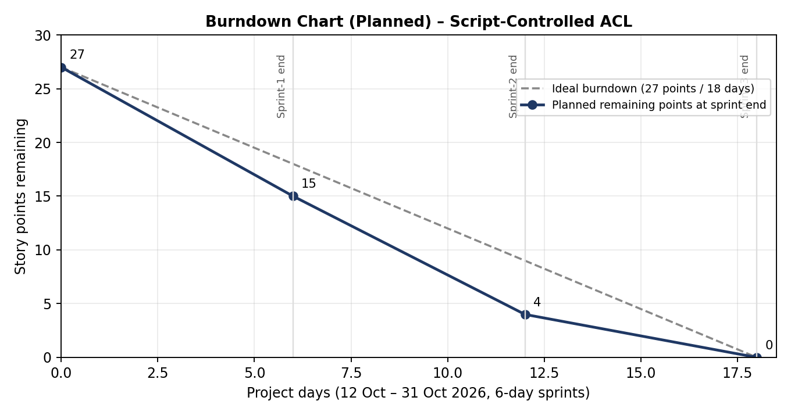
Reference:
https://www.servicenow.com/docs/bundle/zurich-it-business-management/page/product/agile-development/concept/basics-agile-development.html
https://www.servicenow.com/docs/r/4Pll~Vzr5Rr79UNYLnUdJw/uU77liFFv7j4Bx4XUJRRCA
https://docs.servicenow.com/bundle/newyork-it-business-management/page/product/agile-development/concept/agile-development-process-flow.html
https://docs.servicenow.com/bundle/sandiego-it-business-management/page/product/agile-development/task/create-a-story.html
https://www.servicenow.com/docs/r/yokohama/platform-security/access-control/exploring-access-control-list.html?contentId=oczJQGZK~1lGzH~ITrwZHg

